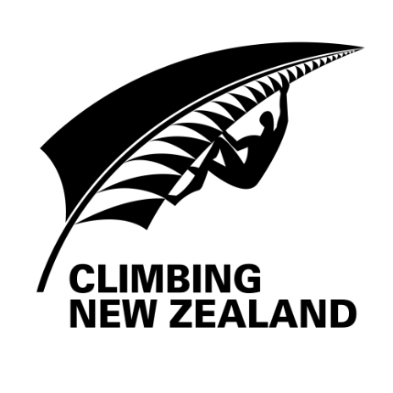 | 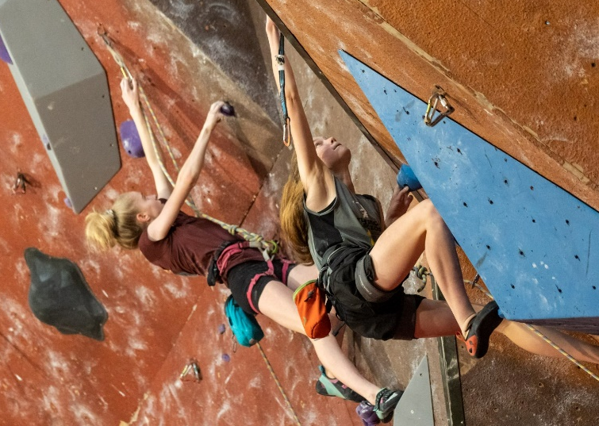
NATIONAL CHAMPIONSHIPS

SPONSORSHIP PROGRAM

2023 / 2024 Competition Dates:
16th Sep ‘23 | Open Bouldering Championships | Northern Rocks, Auckland
TBC Oct ‘23 | Youth and Masters Bouldering Championship | TBC
Feb / Mar 2023 TBC | National Speed Championships | Blake Park, Mount Maunganui
Mar 2024 TBC | Youth, Masters and Para-Climbing Lead Championships | Venue TBC
TBC Mar 2024 | Open Lead Championships and Youth Selection event | Venue TBC

Note the additional event planned for the 2023/24 season that will be part of this sponsorship programme.
For more than 25 years Climbing New Zealand has organised New Zealand’s premier sport climbing competition events and National Championship series. Climbing New Zealand is affiliated with the International Sport Climbing Federation and is sanctioned to run IFSC events in New Zealand and Oceania. The Climbing New Zealand National Championship series comprises sport climbing, bouldering, speed climbing and para-climbing. The events feature New Zealand’s top climbers and are used as the qualification for the World Championships and Olympics. For many young climbers, the IFSC World Youth Championships is the pinnacle of their sporting career.
Sport Climbing debuted at the Tokyo Olympics in 2021 and is confirmed for Paris 2024 and LA 2028 cementing its place as a growing international sport.
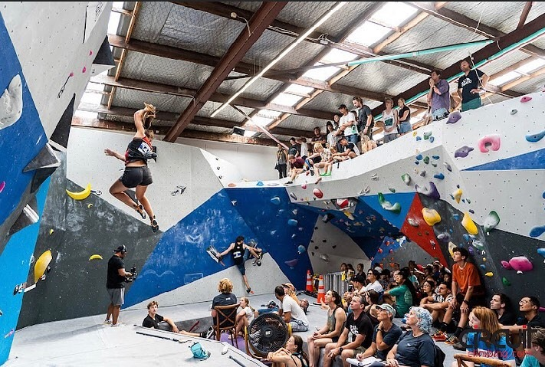
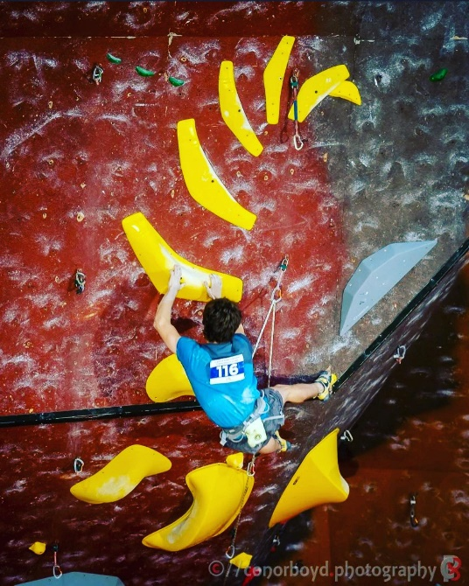
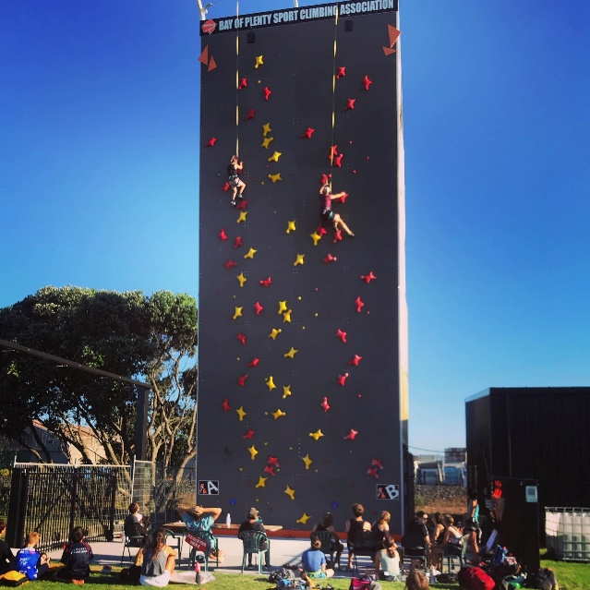
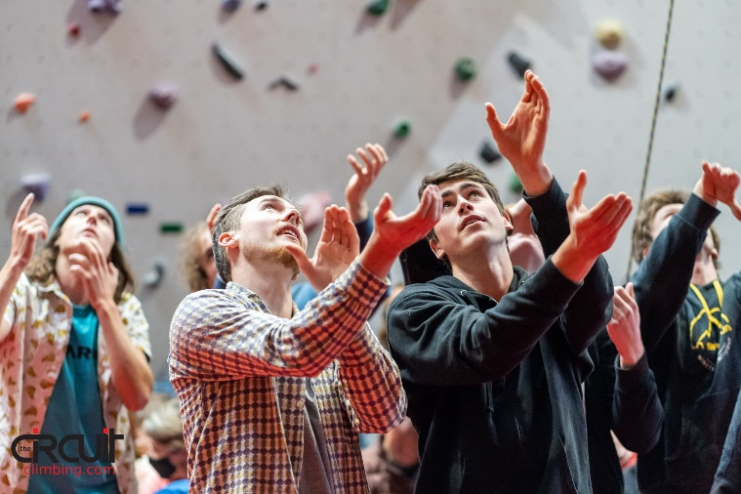

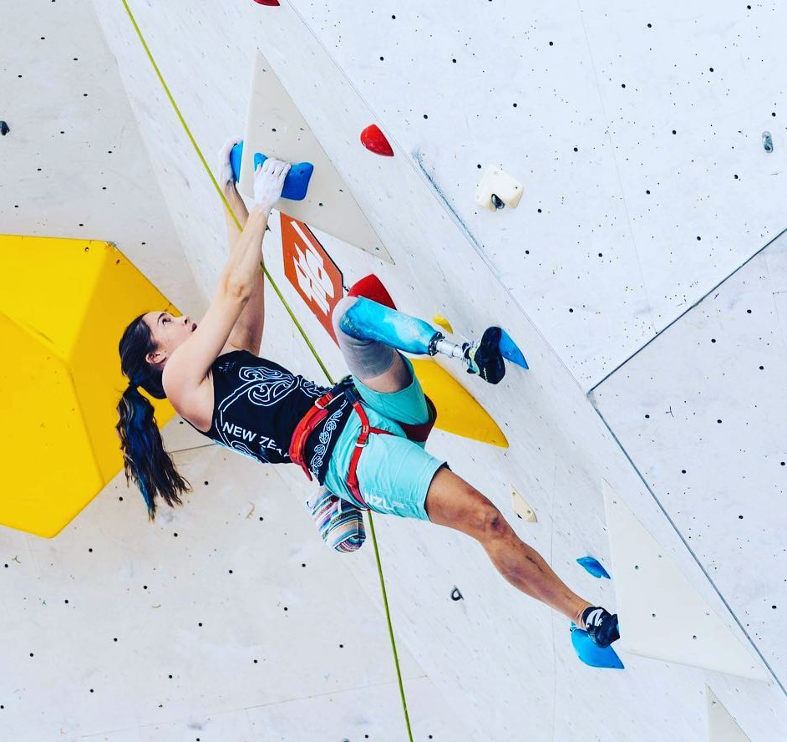
LAST YEAR’S EVENTS
The 2022/2023 season had us continue to have to adjust the events programme with Covid still impacting into 2023. We have two events delayed as a result. We did manage to run all of events and as we plan for 2023/24 we hope to not be impacted again. Through the ongoing challenges of Covid, with the commitment and determination of the CNZ organising teams, volunteers, athletes, Gym hosts and sponsors we were able to success hold the four competitions and overall grow the participation. Event held were: Youth and Masters Bouldering Champion-ship in Christchurch, Open Bouldering Championships in Auckland, Lead and Para-Climbing Championships in Christchurch and Speed Championships in Mount Maunganui.
In 2022, we saw Kiwis, competing in World Cup and World University events in: Salt Lake City USA, Brixen Italy, Innsbruck Austria and Villars Switzerland.
Rachel Maia completed the Para-climbing season with 2 4th places and a silver medal in Salt Lake City. Rachel will be competing internationally again in 2023 culminating at the IFSC World Championships in Bern, Switzerland.
Already in 2023 We have had 20 athletes competing in the Australian Youth Championships, with a number of podium finishes across bouldering and lead disciplines.
We have also had 5 athletes competing in the Speed discipline at IFSC Speed Championship events in Indonesia in 2022, and Korea, Switzerland and France in 2023 as well as at the IFSC World Championships in Bern. These athletes have been part of a high performance Speed Climbing programme running in Mount Maunganui and supported by HPSNZ. We are excited to see their progress through 2023.
In November 2023 we will also have athletes heading to Melbourne, Australia to compete in the IFSC Oceania Olympic Qualification event. Two disciplines are to be included in the Paris Olympics with a combine Lead-Boulder event and a separate Speed event. We will have athletes competing in both.
Post the 2022/23 we reviewed out competition formats and made the decision to split our lead event into two events for 2023/24, with the Open’s event separating from the Youth and Masters events. This allows us to present a better quality event and support for route setters in their work. The additional lead event will double of an additional selection competition for our Youth athletes looking for selection into the Youth Team for the World Youth Championships.
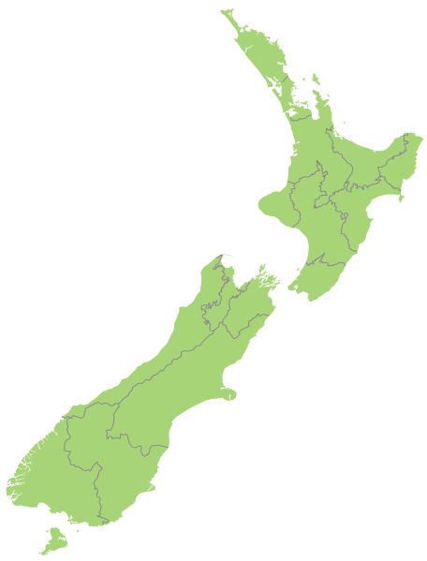
MT MAUNGANUI
AUCKLAND
CHRISTCHURCH

Facebook followers competitors
180
2900
1851
800
website visits/month Instagram followers

COMPETITIONS IN THE MEDIA
Past media coverage includes: Sky Sport Next, Sky TV, The Crowd Goes Wild, TV One, New Zealand Herald, The Bulletin, Christchurch Press, Otago Daily Times, Waikato Times, East & Bays Courier, Rotorua Daily Post, Western Leader, North Shore Times, Eastern Courier, Western Leader, Central Leader, NZ Alpine Club “The Climber” magazine, Radio Sport, Today FM,

PAST SPONSORS
 |  | 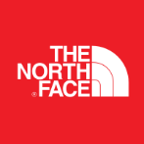
 | 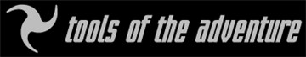
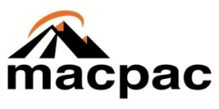 |  | 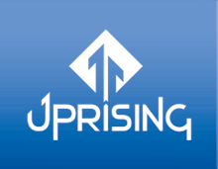
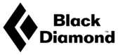 | 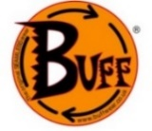 | 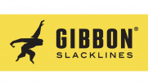 | 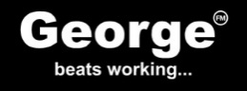
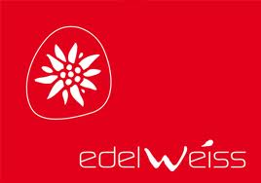 |  |  | 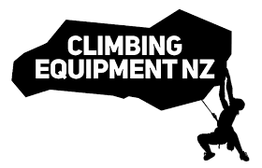
 |  |  | 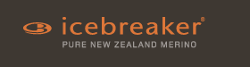

SPONSORSHIP OPPORTUNITIES

SPONSORSHIP | Title | Platinum | Gold | Silver
LEVEL | $10,000 | $4,800 | $2,000 | $800
 | Value in kind | Value in kind | Value in kind | Value in Kind
Number of sponsor places | 1 | 1 | 3 | 8
Wall banners & feather signs ¹ |  |  |  | 
Podium backdrop - exclusive ¹ | 
Podium backdrop - non-exclusive |  |  | 
Series Poster - exclusive | 
Series Poster – non-exclusive |  |  | 
Competitors Bibs |  | 
Entry forms |  | 
Start lists |  | 
Results board |  | 
Event program |  |  |  | 
Web Site |  |  |  | 
Facebook and social media |  |  | 
Acknowledgement at press release and advertising related to events |  | 
Shout out by MC |  |  | 
Giveaway packs ¹ |  |  | 
Booth Space |  | 

Notes: 1, Supplied by Sponsor 2, Sponsorship obligation can be fulfilled by a combination of cash and product (value in kind) to a maximum of 50% product or $1000; that is Gold could provide up to $1000 of product plus $1000 cash and Silver may be all product and no cash.

Limited spots available RSVP by 31 Aug 2023!

Climbing New Zealand
SPONSORSHIP APPLICATION FORM
The sponsorship agreement can be downloaded from here:
https://www.climbing.nz/sponsorship/

COMPANY INFORMATION
Company Name ________________________________________
Company Address _______________________________________
Company Contact & Title _________________________________
Contact Phone # ____________ Contact E-Mail _______________
Key Brand _____________________________________________
Key Product Category ____________________________________

SPONSORSHIP LEVEL
 Title Sponsor $10,000 (filled for 2023/24)
 Platinum Sponsor $4,800
 Gold Sponsor $2,000
 Silver Sponsor $800
Notes or details about the donation: ________________________
_____________________________________________________
_____________________________________________________
PAYMENT INFORMATION
 Please invoice me at the address listed above.
 Check # ________ Amount Enclosed $____________________
Please make checks payable to Climbing New Zealand
 Direct Credit BNZ account 02-0940-0184145-00

Email to info@climbing.nz

